
Tripoli Motor Testing Division
223 NC Highway 54 West
Chapel Hill, NC 27514
(919) 357 5681 (c)
August 20, 2018

Gary Rosenfield
RCS Rocket Motor Components, Inc.
2113 West 850 North Street
Cedar City, UT 84721

Dear Mr. Rosenfield,

The Aerotech J520W-13A RMS motor was tested on April 21, 2017, May 3, 2018, and August 14, 2018 and is in compliance with NFPA 1125. The motor is certified for hobby rocketry use by the members of the Tripoli Rocketry Association and all approving organizations with reciprocal certifying agreements.

Motor Manufacturer Aerotech Division, RCS Rocket Motor Components
Manufacturer’s Designation J520W-13A RMS for the 38/1080 hardware
Propellant White Lightning
TMT Nomenclature 671 J487

Diameter - 38 mm
Overall Length 19.77” 502.12 mm
Length Inside 19.33” 490.93 mm
Length Outside 0.433” 11.19 mm

Loaded Mass 1.670 lb 757.42 g
Propellant Mass 0.840 lb* 381 g*
Burnout Mass 0.771 lb 349.65 g
* data provided by manufacturer

Burn time 1.377 ± 0.026 sec

Total Impulse 150.9 ± 4.97 lbf.s 671.26 ± 22.09 N.s
Max Impulse 202.93 ± 23.49 lbf 902.66 ± 104.5 N
Average Impulse 109.57 ± 4.63 lbf 487.41 ± 20.60 N
Number of Motors Tested 6

Nominal Measured
Delay Time Data 5 6.227, 6.639 sec
9 9.332, 10.204 sec
13 10.486, 10.047 sec 12.989,12.531 sec

Casing Temp. [NFPA 1125 7.4.1] Passed
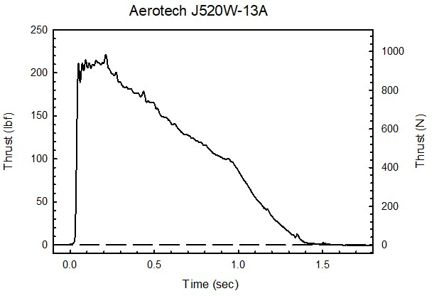

Sincerely,

Alan C. Whitmore
Chair, Tripoli Motor Testing

